**Tomo Step Wedge Helical**

**Purpose:** This procedure lists the steps involved in performing a step wedge helical test on Tomo. A therapist performs this test every morning as part of Tomo warmup.

**At Tomo console**

1. Log in to Tomo, if necessary. You may log in as yourself or as a therapist (username *therapist* and password *therapist1*).

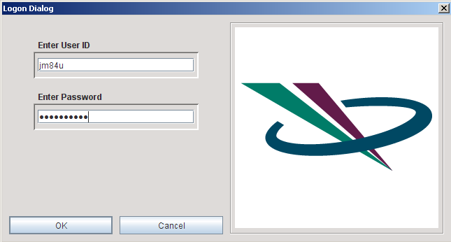

1. Click the Patient Selector. Navigate to patient **zzzzz TQA Step Wedge Helical**, disease **Disease Name**, and plan **Plan_01**. With this plan selected, click **OK**.

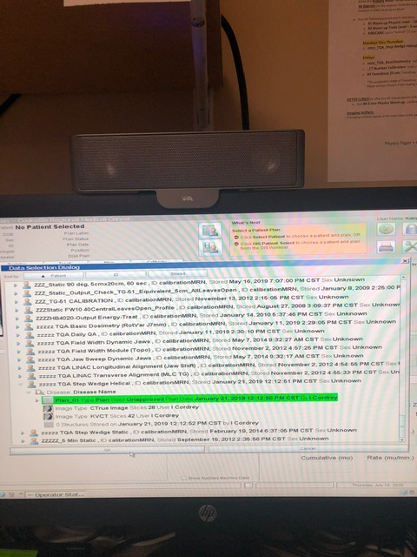

1. Navigate to the **Calibrate** tab. Navigate to the **Run** tab. Right-click a previously completed procedure and click **Generate QA procedure**.

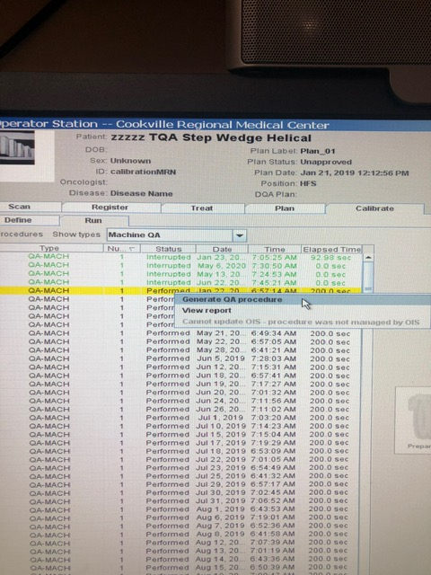

1. Select the new procedure and click **Prepare calibration**.

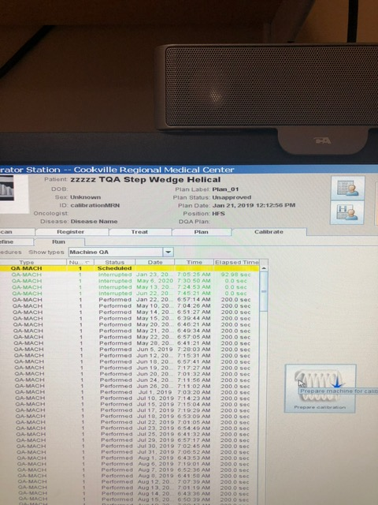

**In Tomo tx room**

1. Turn on the green lasers.

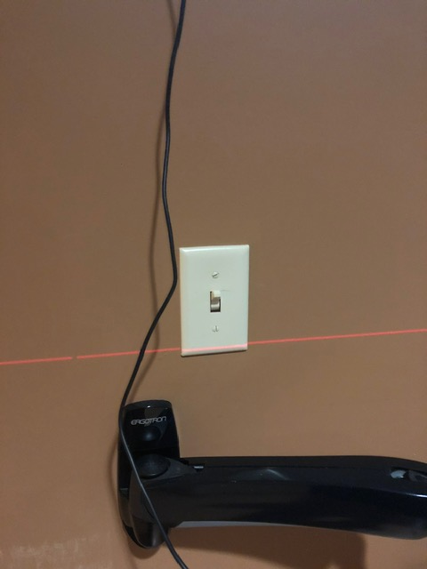

1. Place the indexing bar at position 3 on the couch.
2. Get the step wedge phantom from the case in the top cabinet.

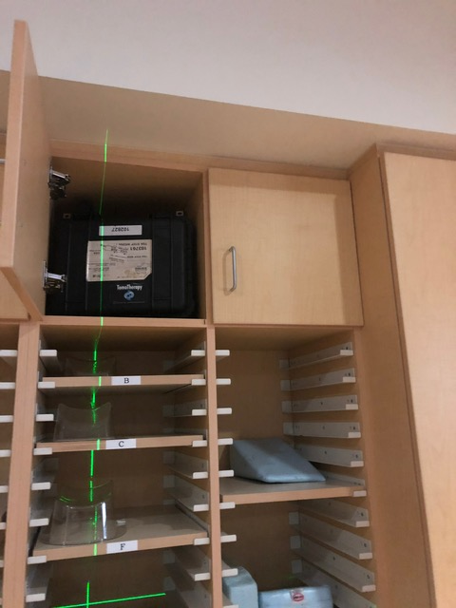

1. Place the step wedge phantom against the indexing bar. Align the phantom laterally and longitudinally with the overhead, green, virtual isocenter lasers. The lasers should be aligned with the cross hair engraved on the step wedge.

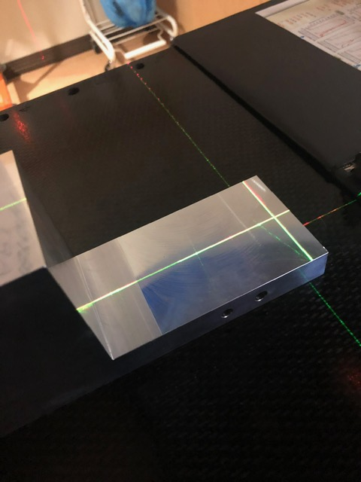

1. Align the green virtual isocenter lasers that shine through the bore, with the second stair on the phantom. The laser should be split as shown in the image below.

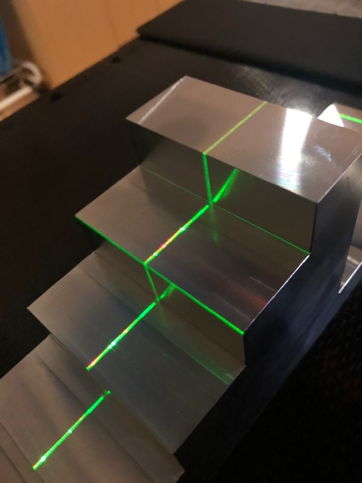

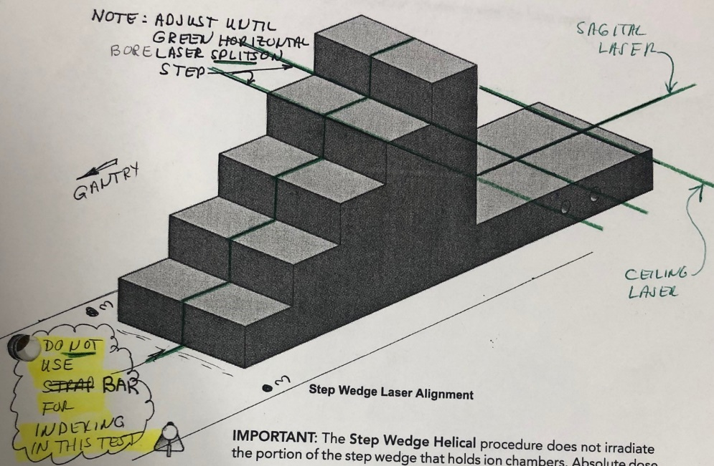

1. Remove the indexing bar from the table!
2. On the **Main** tab, press **Ready**.

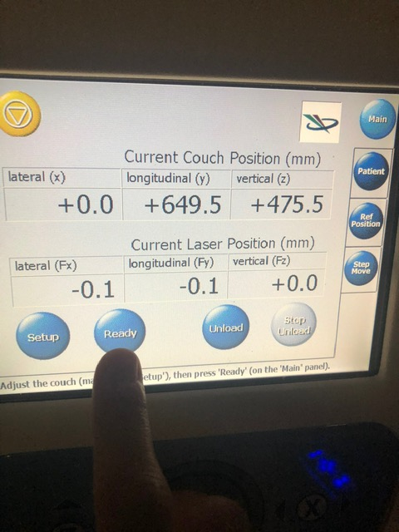

Press **Yes**.

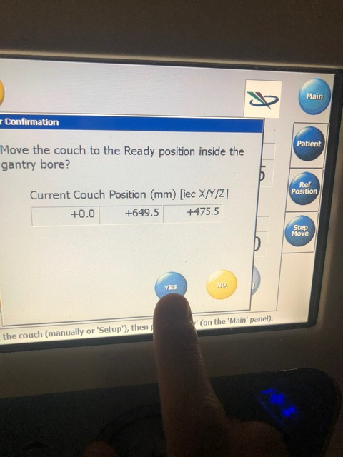

1. Exit the treatment room and close the door.

**At Tomo console**

1. On the console, turn the key to **Treat**. When the green **Ready** light comes on, press the green **Start** button.

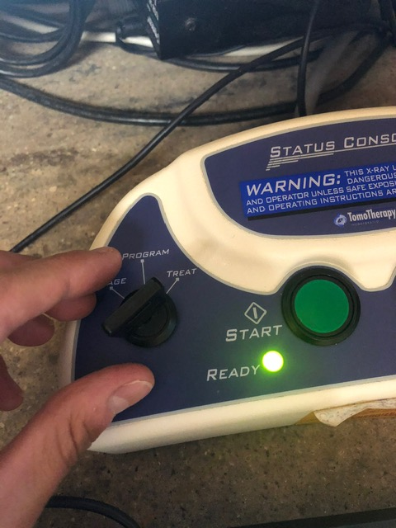

1. After the procedure is complete, you should see the following message.

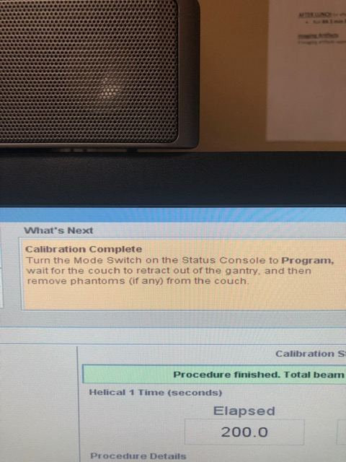

Turn the key to **Program**.

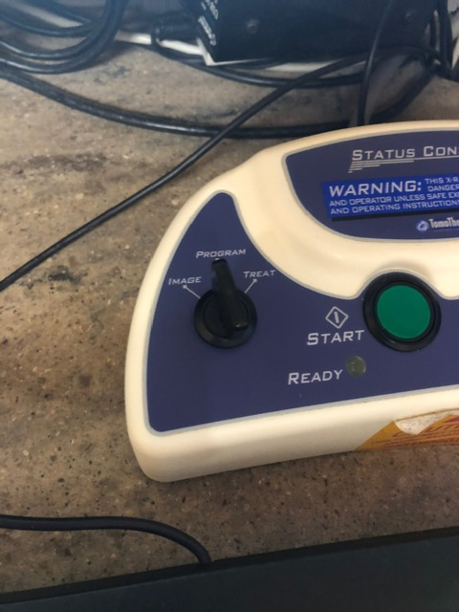

**Note:** As of July 2020, the below information applies only to physicists.

1. Go to Internet Explorer.

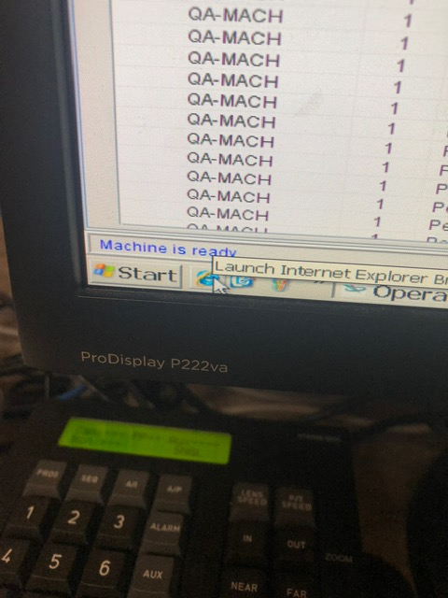

1. Log in to TQA.

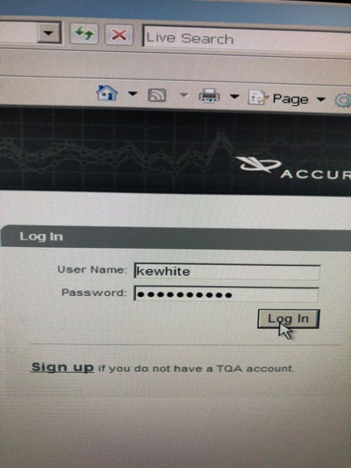

1. Locate the test you just performed.

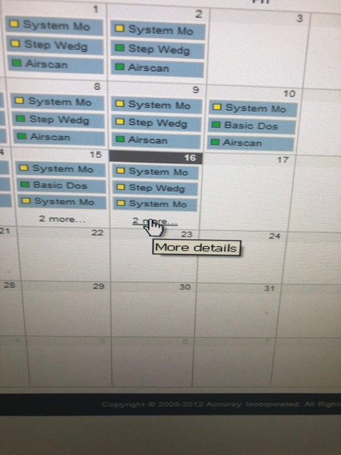 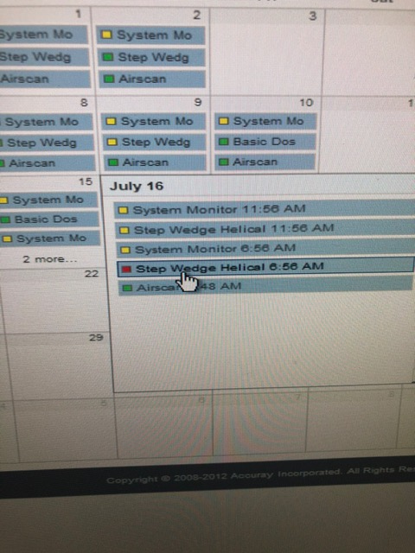

If the square beside the name of the scan is red, as in the above photo, the test failed. Click the test. Click **Report**.

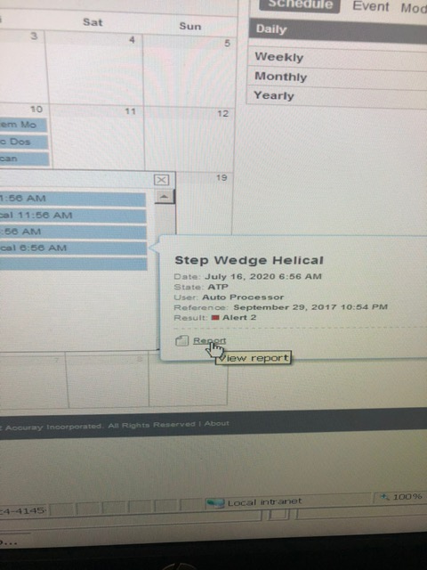

1. Note which subtest(s) failed. Failures (red) are under **Alert 2**; warnings (yellow) are under **Alert 1**.

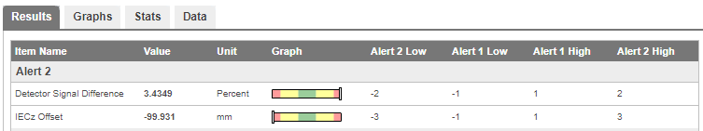

Failing offsets generally indicate sloppy setup. Detector Signal Difference usually means that the indexing bar was left on the couch during the test.